TELOS Stress Device
A simple, precise way to X-ray test knee and ankle ligaments — before and after treatment.
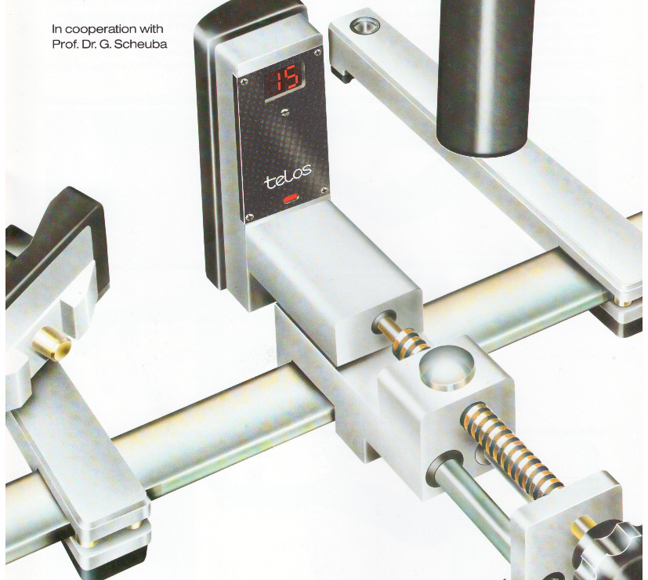  The TELOS stress unit, positioned for a standardised knee examination. | What it does, in plain terms  • It gently and precisely stresses a knee or ankle joint by a known, repeatable amount.  • An X-ray is taken while the joint is held in this position — showing exactly how loose or stable a ligament is.  • The digital readout displays the exact force applied, so every test is standardised and comparable.  • The same test can be repeated after surgery to objectively show improvement.  Why hospitals use it  • Removes guesswork from ligament laxity diagnosis — no reliance on the examiner's hand strength alone.  • Standardises pre- and post-treatment comparison for the same patient.  • Protects the patient — the frame positions the limb correctly, minimising repeat X-rays.
Four standard examinations
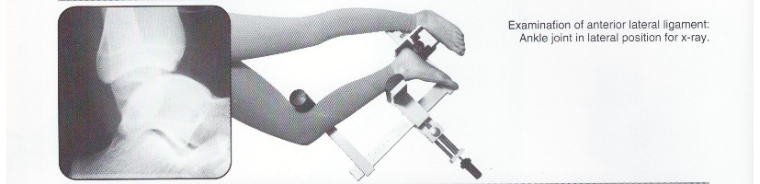  Ankle ligament stress test — lateral X-ray view | 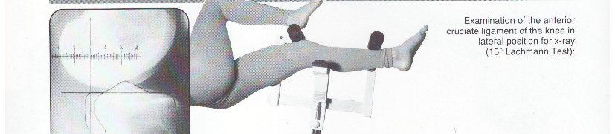  ACL stress test — 15° Lachmann position
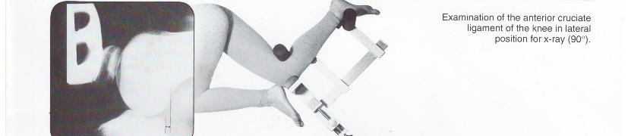  ACL stress test — 90° position | 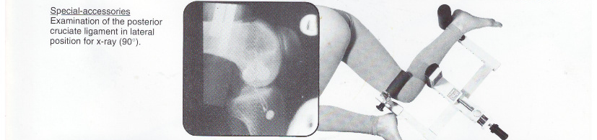  PCL stress test — 90° with special accessory
How the examination works
1 Position  The limb is placed in the TELOS frame, which holds the joint in the correct standard position. | 2 Apply force  A calibrated, gentle force is applied and shown on the digital readout — the same force every time. | 3 X-ray & compare  The X-ray is taken under stress, giving an objective, repeatable measure of ligament stability.
TELOS Stress Device | HSN 90189029 | GST 5% — Available through Everest Medical Technologies Pvt. Ltd.

